My Big Idea - Smart Plant Pot

The “Smart Plant Pot” is a device which reacts to weather and pollen count forecasts to inform its user what to expect for the day ahead. This function was chosen because my research showed that the most performed task on smartphones is checking the weather [1]. This suggests that our society finds weather information vital for our day to day life.

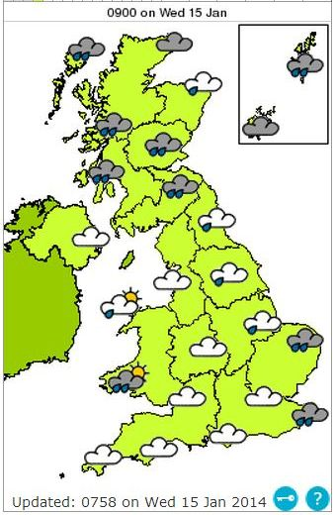

Figure : MET Office Weather Forecast

The addition of pollen count tracker was added to prepare users for other eventualities nature might have for them. With 1 in 5 people in the UK suffering from hay fever [2], the addition of this forecast can boost the device’s functionality without straying away from the product’s nature oriented theme.

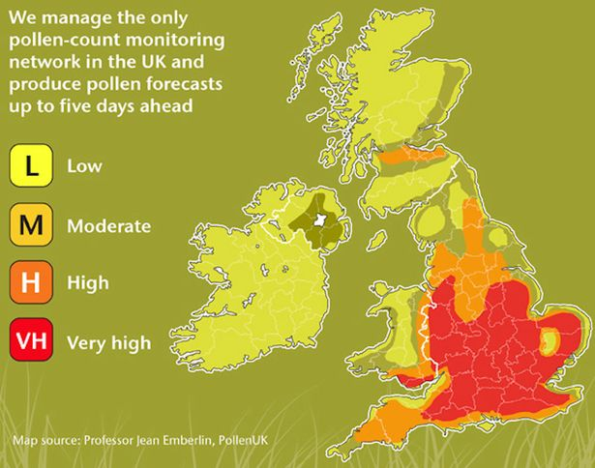

Figure : MET Office Pollen Count Forecast

The device does its job by locating the user’s area through GPS/User Input and taking the weather/pollen count forecasts from the MET Office through the internet. By combining the two information, the device can relay user specific data using visual signals where different light colours represent different outdoor conditions.

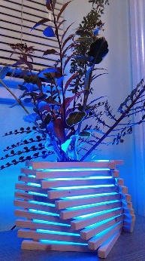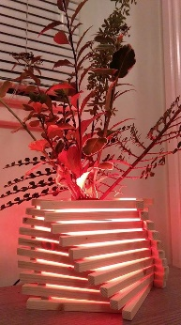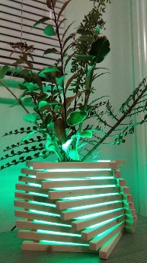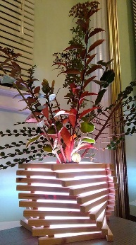

Figure : Smart Plant Pot prototype demonstration

For instance, the device will emit a blue light to tell the user that there’s a high probability that it will rain in his/her area, reminding him/her to bring an umbrella and to dress appropriately. For multiple conditions the device will alternate its colour to give more information.

Since the prototype was developed as a demonstration platform, its capabilities were designed specifically for communicating the idea to other individuals. The prototype produced is incapable of taking external information and reacts only through timed sequence. Given more time, the product can be programmed properly to gather and analyse external information.

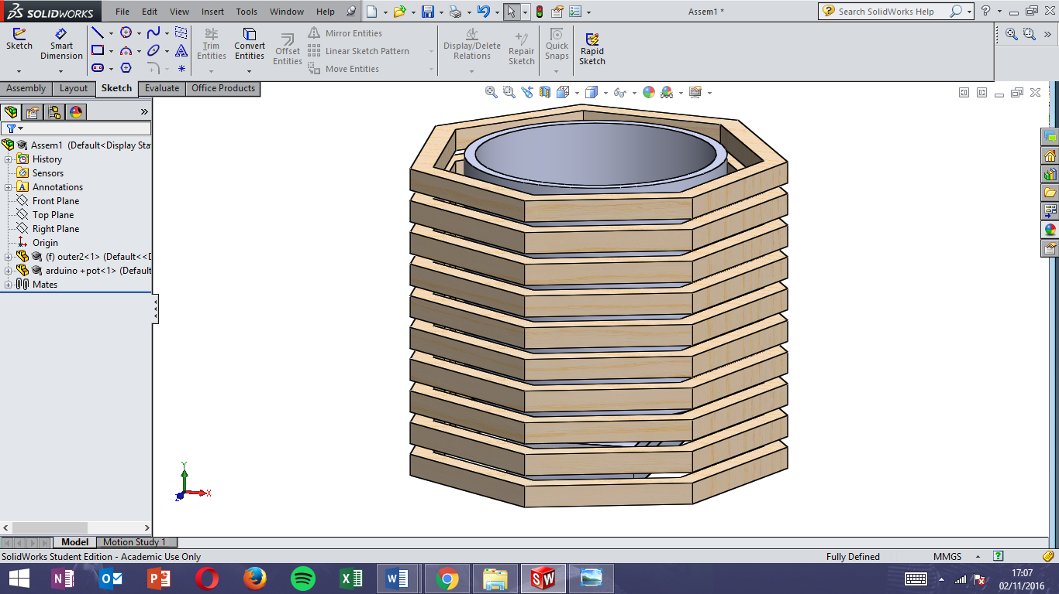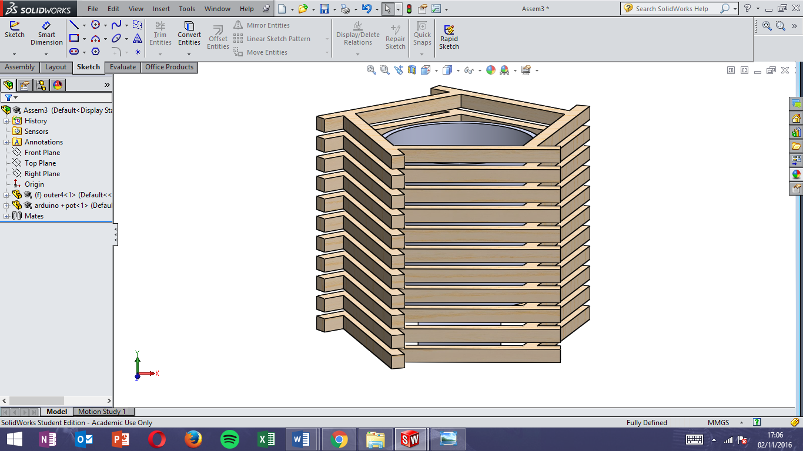 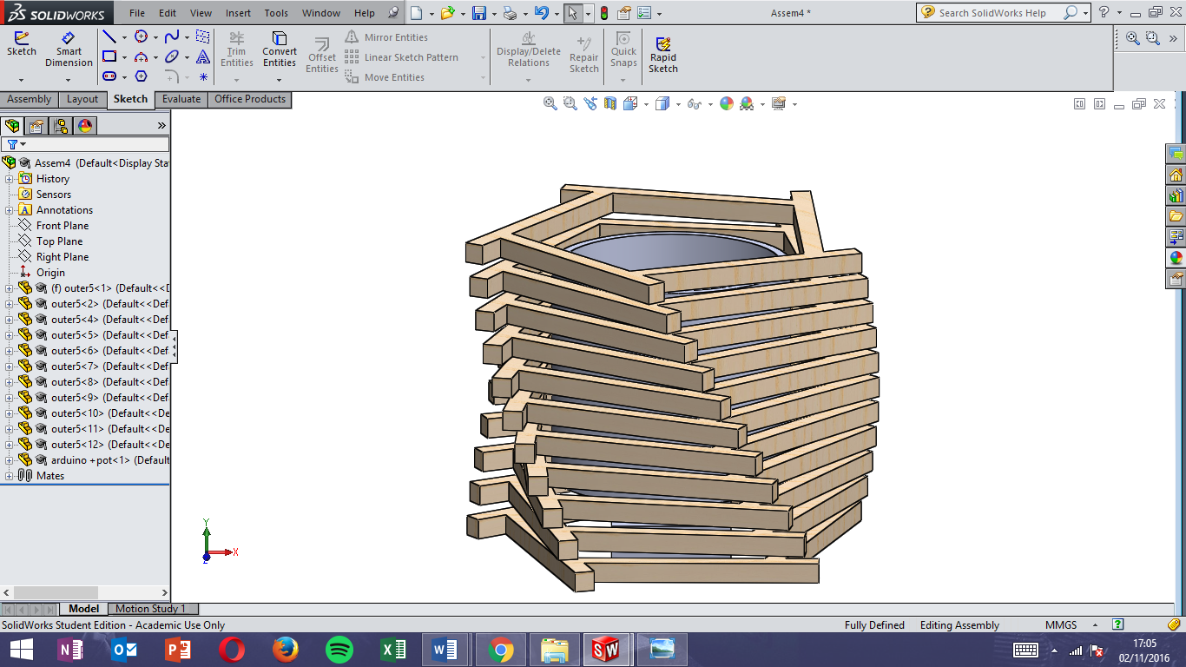

Figure 4: Exterior Design One Figure 5: Exterior Design Two Figure 6: Exterior Design Final

Even though I’m happy with the final exterior design, I believe that additional time could improve the design further. One of the main factors why I decided to produce the prototype’s body, solely, in wood was the lack of time available to produce it in a different way.

Using only wood for the prototype enabled me to produce a full-scale product in a couple of days. This is faster than what it would have taken me if I used other materials, however my design was limited to simpler geometries since producing complex shape from wood would take a large amount of time.

If given more time, I would develop a design which utilises multiple materials (wood, glass and plastic). Wood will still be used as the main frame of the product but glass will be used to handle water based plants. Instead of using tape for securing the electronics, a plastic case will be produced for housing the sensitive components.

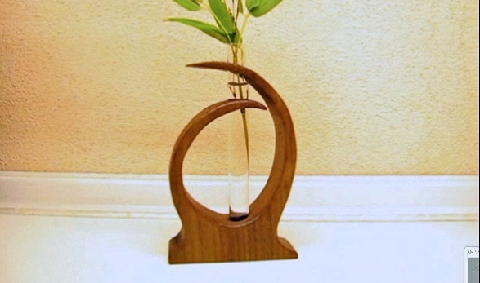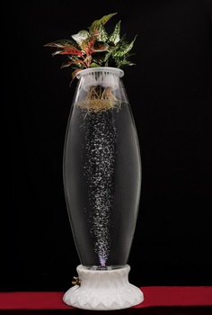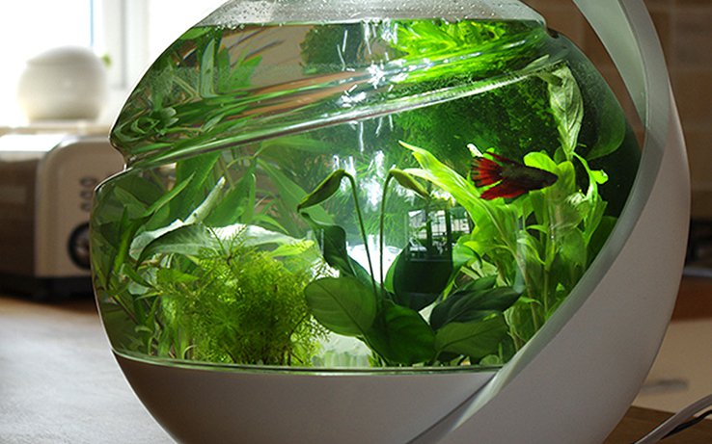

Figure 7: Future Improvement - Combine light, wood and water based plant for natural design

The main benefit of using this product is the convenience and improved weather preparedness of its user. The device can be placed on bed side tables and update its user about the weather before they get out of bed in the morning.

Who Am I?

-I’m a mechanical engineering graduate with some experience in Arduino.

-For my undergraduate project I designed and built a working tensile machine prototype. For this project, I was responsible for designing all of the electrical circuit, CAD components and programming. After designing the product, I was also tasked with the manufacturing and testing of the device.

-Prior to joining this course, I have no experience in product idea generation, storytelling and video presentation.

Source

[1]<http://www.huffingtonpost.com/2012/08/21/the-number-one-use-smartphone_n_1818632.html>

* Smartphone’s number one use

[2] <http://www.metoffice.gov.uk/health/public/pollen-forecast>

- MET Office Pollen Count